1 per student on card

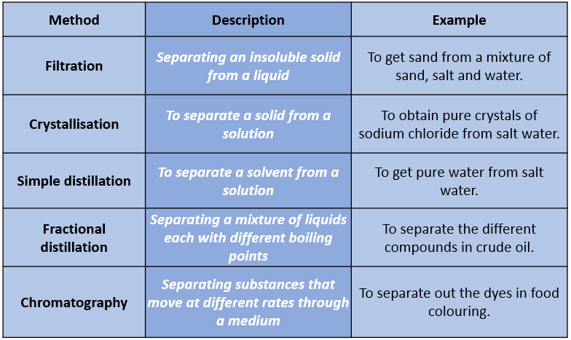

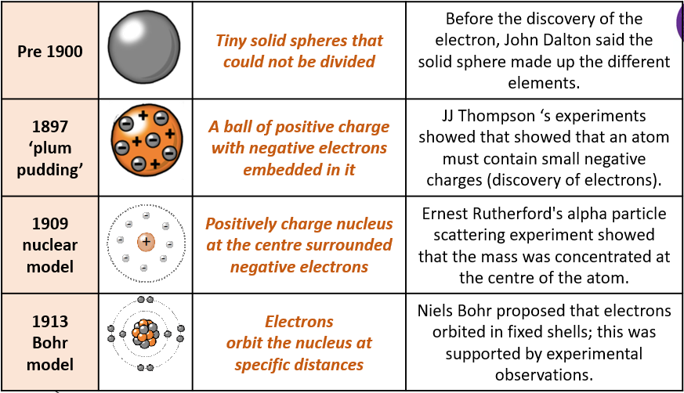Have a go at this one too … but turn over 4 cards for this game …

Paired exercise – cut in half

Teach me something … Student 1

|  |  |  |
| --- | --- | --- |
| **Atom** | ***The smallest part of an element that can exist*** | Have a radius of around 0.1 nanometres and have no charge (0). |
| **Element** | ***Contains only one type of atom*** | Around 100 different elements each one is represented by a symbol e.g. O, Na, Br. |
| **Compound** | ***Two or more elements chemically combined*** | Compounds can only be separated into elements by chemical reactions. |

Teach me something … student 2

